Activity 1: CRUD Operations Practice  
  
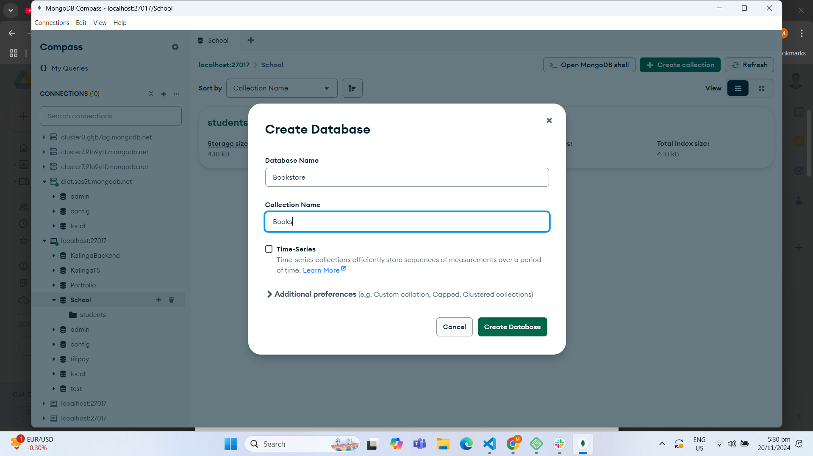

a) Create Operation: Insert at least three book documents with different fields such as title, author,

genre, and publication year.  
  
b) Read Operation: Retrieve all the book documents in the "Books" collection. Retrieve a specific book document based on its title or author.  
  
c) Update Operation: Update the genre of a book document. Update the publication year of a book document.  
  
**Genre**  
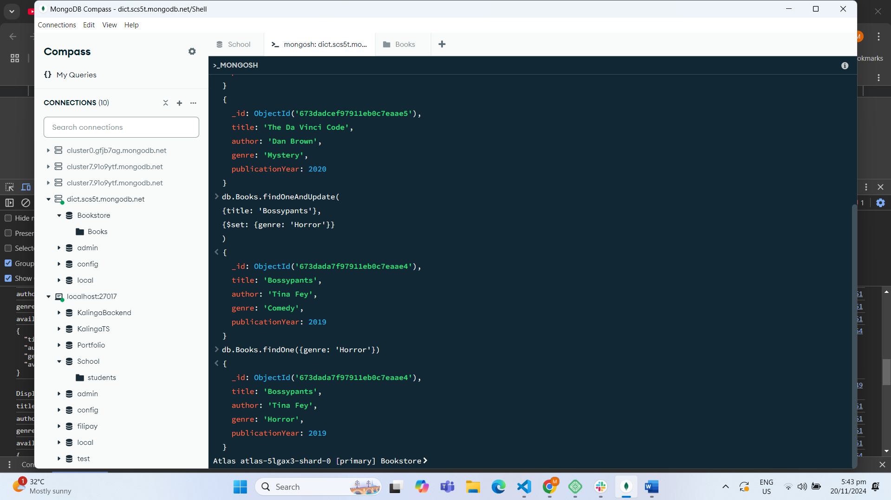  
  
**Publication Year**

d) Delete Operation: Delete a book document based on its title or author. After each operation, verify the changes by re-reading the data from the "Books" collection.  
**title**

**Author**

DELETE DATABASE FROM ATLAS  
  
